

**Department of Mechanical & Nuclear Engineering**

**Nuclear Reactor Theory (0407308)**

**Midterm Examination**

**Spring 2023/2024**

**Time/Date: 09:30-10:30 am February 29, 2024**

|  |  |
| --- | --- |
| **Name** |  |
| **Student ID** |  |

**Rules:**

1. Begin by writing your name and student ID.
2. Write the answer neatly and clearly.

**For Instructor:**

|  |  |  |  |  |  |
| --- | --- | --- | --- | --- | --- |
| **Question** | **1** | **2** | **3** | **4** | **Total** |
| **Grade** |  |  |  |  |  |
| **Out of** | 5 | 8 | 8 | 4 | 25 |

1. (5 points)
2. (2 points) What is neutron multiplication factor?

$$k=\frac{\text{number of neutrons in current generation}}{\text{number of neutrons in previous generation}}$$

(3 points) Complete of the following chart of neutron life cycle

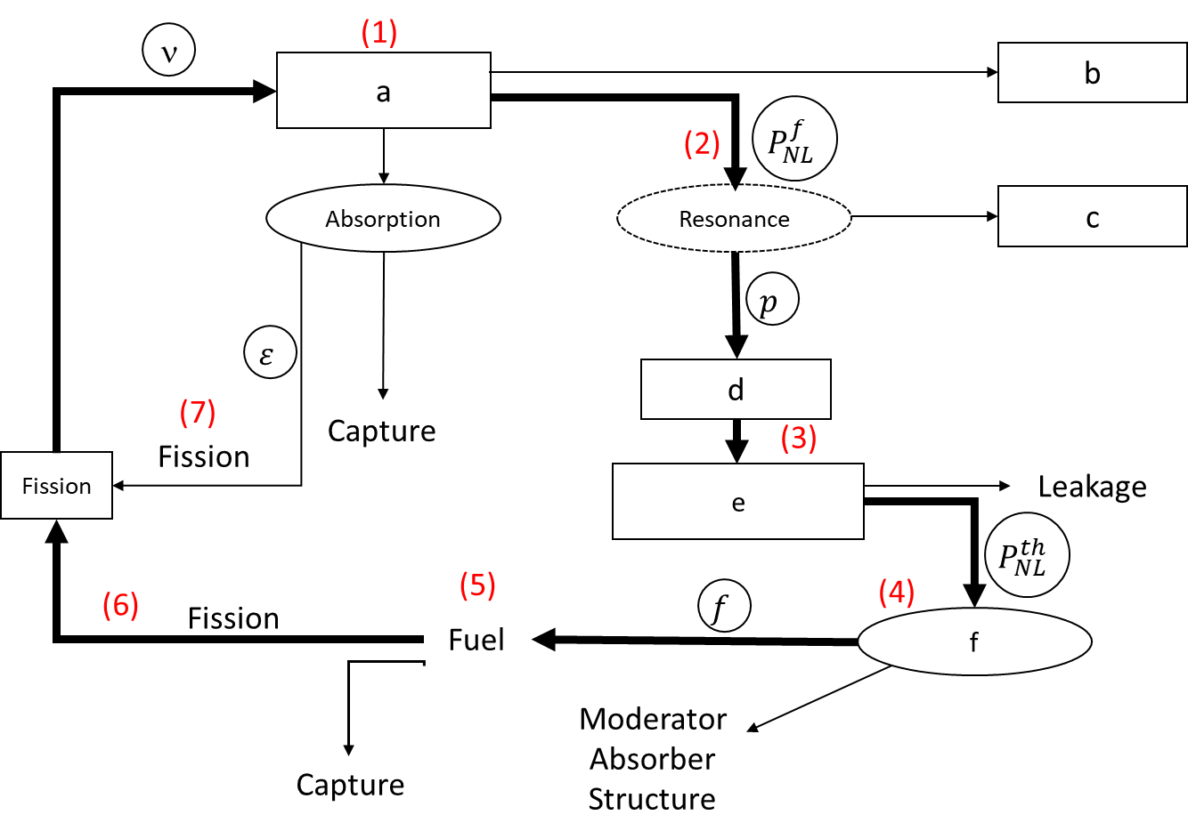

|  |  |
| --- | --- |
|  | Write your answer here |
| a | Fast neutrons |
| b | Leakage |
| c | Capture |
| d | Escape |
| e | Thermal neutron |
| f | Absorption |

1. (8 points) The neutron transport equation in its complete form is

$$\frac{1}{v}\frac{∂ϕ}{∂t}+\hat{Ω}∙∇ϕ(r,E,\hat{Ω},t\text{) +}Σ_{t}\left(r,E\right)ϕ\left(r,E,\hat{Ω}, t\right)$$

$$=\int_{4π}{d{\hat{Ω}}^{'}}\int_{0}^{∞}{dE^{'}}Σ_{s}\left(E^{'}→E,{\hat{Ω}}^{'}→\hat{Ω}\right)ϕ\left(r,E^{'},{\hat{Ω}}^{'}, t\right)+s\left(r,E,\hat{Ω},t\right) (1)$$

a) (2 points) In Equation (1), what is the scattering term and what is the leakage term?

b) (3 points) Simplify Eq. (1) for one-speed neutron

c) (3 points) Simplify Eq. (1) for one-group energy steady state

**Solution:**

a. The scattering term: $\int_{4π}{d{\hat{Ω}}^{'}}\int_{0}^{∞}{dE^{'}}Σ_{s}\left(E^{'}→E,{\hat{Ω}}^{'}→\hat{Ω}\right)ϕ\left(r,E^{'},{\hat{Ω}}^{'}, t\right)$

The leakage term: $\hat{Ω}∙∇ϕ(r,E,\hat{Ω},t\text{) }$

b. One-group energy:

$$\frac{1}{v}\frac{∂φ}{∂t}+\hat{Ω}∙∇φ(r,\hat{Ω},t\text{) +}Σ_{t}\left(r\right)φ\left(r,\hat{Ω}, t\right)=\int_{4π}{d{\hat{Ω}}^{'}}Σ_{s}\left({\hat{Ω}}^{'}→\hat{Ω}\right)φ\left(r, {\hat{Ω}}^{'}, t\right)+s\left(r,\hat{Ω},t\right)$$

b. One-group energy steady state:

Thus,

3. (8 points) The neutron transport equation in its complete form is

In a thermal nuclear reactor at the beginning of its life for every 1,000 neutrons, 450 neutrons are absorbed in 235U, 225 neutrons are absorbed in 238U, 125 neutrons are absorbed in coolant and cladding, 200 neutrons leak out from the geometrical core boundaries, and ν is 2.43.

1. (3 points) Calculate the multiplication factor for this reactor.
2. (3 points) What is the conversion ratio value for this reactor?
3. (2 points) The control rods are then inserted such that now 410 neutrons are absorbed in 235U, 215 neutrons are absorbed in 238U, 225 neutrons are absorbed in coolant, control rods and cladding, and 150 neutrons leak out from the geometrical core boundaries. If the mean neutron generation lifetime is 10-4 sec and the initial neutron population is 1013 neutrons/cm2, what is the change in the neutron population 1 second after the rods are inserted?

**Solution:**

1. Calculate the multiplication factor for this reactor.

Assume that all neutrons absorbed in U235 cause fission reaction

k1 =450*2.43/1000=1.093

b. What is the conversion ratio value for this reactor?

$CR=\frac{\text{Fissile Material Produced}}{\text{Fissile Material Destroyed}}$ = $\frac{\text{225}}{\text{45}\text{0}}$ =0.5

c. The control rods are then inserted such that now 410 neutrons are absorbed in 235U, 215 neutrons are absorbed in 238U, 225 neutrons are absorbed in coolant, control rods and cladding, and 150 neutrons leak out from the geometrical core boundaries. If the mean neutron generation lifetime is 10-4 sec and the initial neutron population is 1013 neutrons/cm3, what is the change in the neutron population 1 second after the rods are inserted?

k2 =410*2.43/1000=0.996

=7.47

4. (4 points)

a. (2 points) Classify neutron on the graph into thermal, epithermal (intermediate) and fast neutron due to its energy range.

b. (2 points) The average number of fission neutron (ν) depends on what factors?

**Solution:**

a.

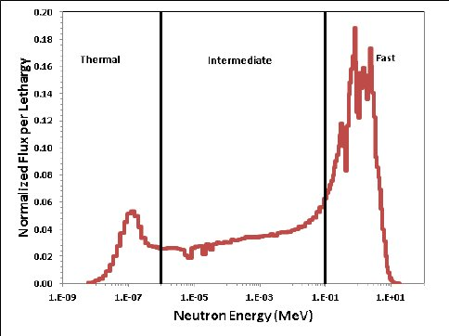

1. Thermal neutron: 0<E≤0.1 eV
2. Epithermal neutron: 0.1 eV<E≤100 KeV
3. Fast neutron: 100 KeV<E≤10 MeV

b. The average number of fission neutron (ν) depends on the energy of incident neutron and the fissile nuclide.

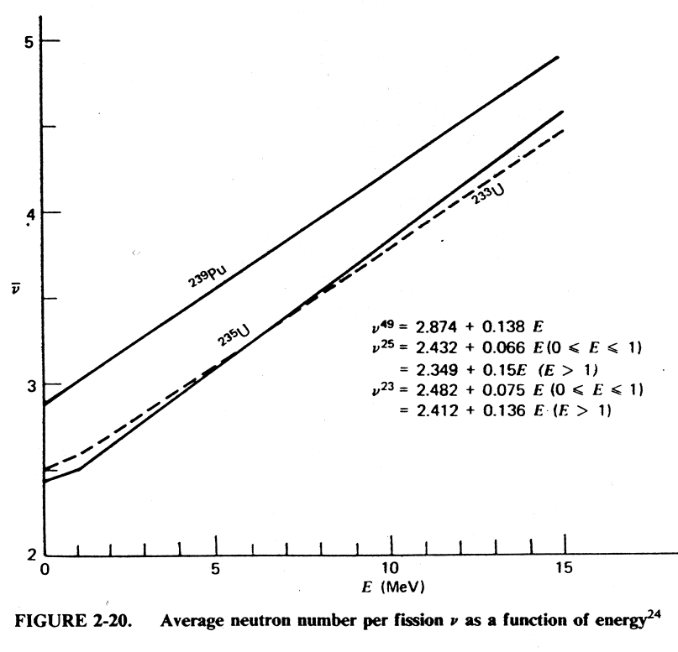

**Bonus question**: Explain the Self-Shielding effect on heterogeneous reactor core configuration.